Sri Lanka Institute of Information Technology


IT3101 – Data Warehousing and Business Intelligence
Year 3, Semester 1- 2026
Group Assignment – Report
Group: WE.DS.01.02
DS-57
Design and Implementation of a Data Warehouse and Business Intelligence Solution

Registration no | Name
IT24102178 | Peiris W.U.M
IT24101780 | Wanigasekara Y.A.
IT24102310 | Jayawardena H.S.P.P
IT24101808 | Jayawardane K.V.G.P.C.A.

1. Introduction
This report details the design and implementation of an end to end data warehouse and business intelligence solution tailored for an online e-commerce toy store. The project fulfills the eight core requirements outlined in the assignment brief, encompassing dataset selection, architectural design, data integration, and the extraction of actionable business insights via interactive dashboards.
The dataset utilized is the Maven Fuzzy Factory e-commerce database, which comprehensively captures website sessions, page views, orders, order items, and refunds. To satisfy the requirement for heterogeneous data sources, the dataset was restructured into three distinct formats (CSV, Excel, and JSON) prior to loading. A staging database and a dimensional data warehouse were subsequently developed using Microsoft SQL Server. The Extract, Transform, Load (ETL) pipeline was implemented exclusively using T-SQL to maintain transactional integrity within the database environment. Microsoft Power BI was employed for the presentation layer to construct the BI dashboards. Python was utilized solely during the preliminary data preparation phase to format the source files, it was not used for data cleansing or database loading.
Tools Utilized:
- Database and Warehouse: Microsoft SQL Server, managed via SQL Server Management Studio (SSMS).
- ETL Pipeline: T-SQL executed within SSMS, utilizing BULK INSERT, OPENROWSET with OPENJSON, and INSERT ... SELECT statements.
- Source File Preparation: Python 3 utilizing the pandas and openpyxl libraries, restricted strictly to reshaping files prior to the extraction phase.
- Dashboards: Microsoft Power BI.
- Diagrams: Internal SSMS database diagramming tool.

2. Task 1: Dataset Selection and Business Scenario Identification

2.1 Dataset Overview
- Business Domain: E-commerce and online retail.
- Purpose of the System: The system captures the complete customer journey on the store's website, encompassing the initial visit (session), page views, order placement, item selection, and post purchase refunds. It functions as the operational backend for a digital storefront and tracks its marketing funnel.
- Business Problem Addressed: The organization aims to evaluate the efficacy of various marketing channels, analyze website conversion rates, and identify product level profitability and refund frequencies. Because this data is distributed across six disparate operational tables, a holistic, unified view is currently unavailable. The proposed data warehouse and BI solution directly resolve this analytical gap.
- Dataset Source: Maven Analytics, utilizing the Maven Fuzzy Factory database (also accessible via Kaggle).
- Dataset Format: Six CSV files accompanied by a data dictionary in CSV format.
- Time Period: Data spans from March 19, 2012, to March 19, 2015, totaling 1,096 days.
Record Counts and Date Ranges:
- website_sessions: 472,871 rows (19 Mar 2012 to 19 Mar 2015).
- website_pageviews: 1,188,124 rows (19 Mar 2012 to 19 Mar 2015).
- orders: 32,313 rows (19 Mar 2012 to 19 Mar 2015).
- order_items: 40,025 rows (19 Mar 2012 to 19 Mar 2015).
- order_item_refunds: 1,731 rows (6 Apr 2012 to 1 Apr 2015).
- products: 4 rows (19 Mar 2012 to 5 Feb 2014, representing launch dates).
Attribute Descriptions:
- website_sessions (One visit to the website): Attributes include website_session_id, created_at, user_id, is_repeat_session, utm_source, utm_campaign, utm_content, device_type, and http_referer.
- website_pageviews (One page viewed during a session): Attributes include website_pageview_id, created_at, website_session_id, and pageview_url.
- orders (One completed order): Attributes include order_id, created_at, website_session_id, user_id, primary_product_id, items_purchased, price_usd, and cogs_usd.
- order_items (One product inside an order): Attributes include order_item_id, created_at, order_id, product_id, is_primary_item, price_usd, and cogs_usd.
- order_item_refunds (One refund on an order item): Attributes include order_item_refund_id, created_at, order_item_id, order_id, and refund_amount_usd.
- products (One product the store sells): Attributes include product_id, created_at, and product_name.

2.2 Dataset Suitability
This dataset authentically replicates the relational database of an active online retailer. The tables are interconnected via natural keys (e.g., session to page views, session to order, order to order items), successfully mimicking an Online Transaction Processing (OLTP) source environment. The volume of data (nearly half a million sessions and over 32,000 orders) spanning three years provides sufficient depth for meaningful seasonal and channel based analysis. Furthermore, the dataset contains attributes ideally suited for dimensional modeling (e.g., product, date, marketing channel, device) alongside measurable numerical facts (e.g., price, cost of goods, refund amount). A recognized limitation is the absence of personally identifiable customer demographics or geographic locations; consequently, the analytical model substitutes a traditional customer dimension with granular marketing channel and device dimensions.

3. Task 2: Data Source Identification and Preparation
The entirety of the three year dataset was utilized for this solution to ensure statistical significance across the analytical models.

3.1 Data Sources
To align with the assignment requirement of integrating multiple source formats, the original CSV files were segregated and exported into CSV, Excel, and JSON formats. This design choice accurately simulates a heterogeneous business environment where data originates from distinct operational systems.
- Order Processing System (CSV): Includes orders.csv, order_items.csv, and order_item_refunds.csv. This represents the transactional core detailing sales and refunds.
- Product Catalog (Excel): Includes products.xlsx. This simulates a reference matrix maintained by a merchandising or inventory team.
- Web Analytics Tracking (JSON): Includes website_sessions.json and website_pageviews.json. This represents digital traffic data, typically ingested via an external analytics API.

3.2 Relationships Between Sources
Despite the varying formats, referential integrity is maintained across the files:
- website_pageviews (JSON) links to website_sessions (JSON) via website_session_id.
- orders (CSV) links to website_sessions (JSON) via website_session_id.
- order_items (CSV) links to orders (CSV) via order_id.
- order_item_refunds (CSV) links to order_items (CSV) via order_item_id.
- order_items (CSV) links to products (Excel) via product_id.

3.3 Data Preparation and Integration Strategy
- The initial data was profiled using the pandas library in Python to assess row counts, valid date ranges, and null occurrences.
- A script (prepare_sources.py) was executed to read the baseline CSVs and systematically export them into the designated structural formats (CSV, Excel, JSON).
- Integration is achieved at the database level: BULK INSERT processes the CSVs, OPENROWSET parses the JSON payloads, and direct SQL inserts handle the minimal Excel records.
- Once loaded into the staging environment, the ETL pipeline joins the disparate formats using their shared business keys to populate the unified dimensional model.

4. Task 3: Data Warehouse Architecture Design

4.1 Architecture Diagram
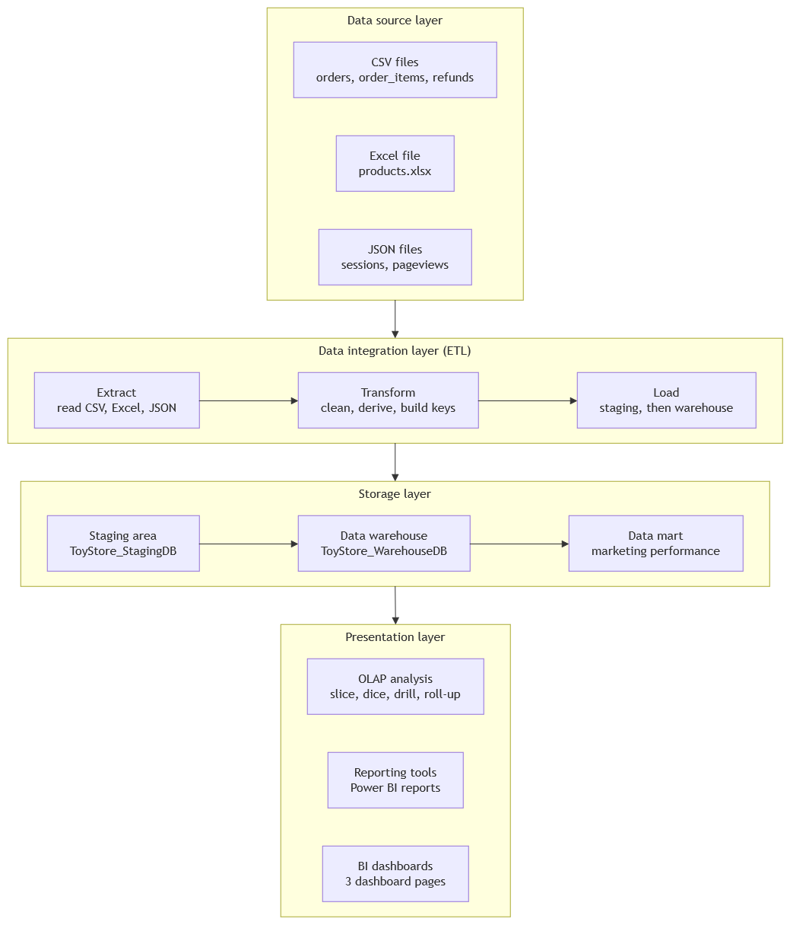

4.2 Architectural Components
- Data Source Layer: Houses the raw operational files (CSV, Excel, JSON). This layer is strictly read-only and remains immutable during the ETL process.
- Data Integration Layer (ETL): Implemented in T-SQL. The extraction phase pulls data into staging, while the transformation phase handles null replacement, dimension generation, surrogate key creation, and derived calculations. Loading is sequence dependent to enforce foreign key constraints, executing within a single database transaction to prevent partial loads.
- Storage Layer: Divided into a Staging Area (ToyStore_StagingDB) to mirror source files and validate data integrity, the central Data Warehouse (ToyStore_WarehouseDB) housing the dimensional model, and a dependent Data Mart created specifically for marketing analytics.
- Presentation Layer: Driven by Microsoft Power BI to facilitate OLAP operations (slice, dice, drill-down, roll-up) and render the required BI dashboards for end-users.

4.3 Rationale for Layered Separation
Separating the architecture into distinct layers ensures data governance and operational repeatability. All data cleansing is centralized in the ETL tier, guaranteeing that BI dashboards query highly structured, validated dimensional tables rather than volatile operational data.

5. Task 4: Dimensional Data Warehouse Design and Implementation

5.1 Business Process and Grain
The core business process modeled is the online customer acquisition and purchasing funnel. Because this funnel operates at varying levels of granularity, the model utilizes a Fact Constellation architecture comprising two fact tables that share conformed dimensions.
- Fact_Order_Items: Grain is set to one row per individual order item. Measures include price_usd, cogs_usd, and refund_amount_usd. It utilizes foreign keys to date, product, and channel dimensions.
- Fact_Sessions: Grain is set to one row per website session. Measures include pageview_count and converted_flag. It utilizes foreign keys to the date and channel dimensions.

5.2 Schema Diagram
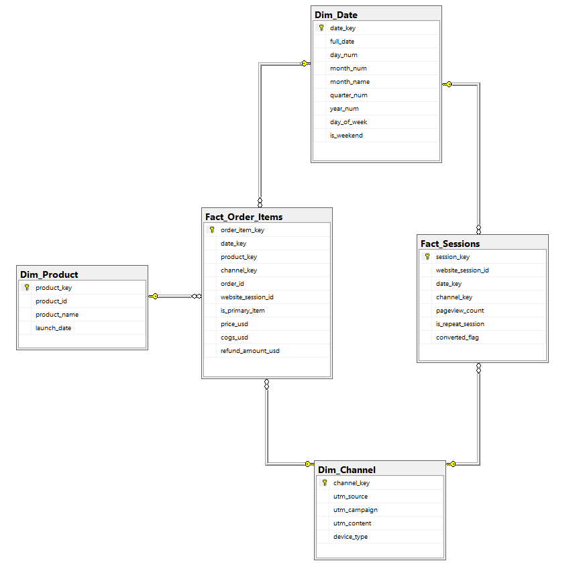

5.3 Dimension Tables
- Dim_Date: Attributes include date_key (PK, format YYYYMMDD), full_date, day_num, month_num, month_name, quarter_num, year_num, day_of_week, and an is_weekend flag.
- Dim_Product: Attributes include product_key (Surrogate PK), product_id (Natural Key), product_name, and launch_date.
- Dim_Channel: Attributes include channel_key (Surrogate PK), utm_source, utm_campaign, utm_content, and device_type.

5.4 Hierarchies and Design Assumptions
The Dim_Date table supports a standard temporal hierarchy (Day → Month → Quarter → Year). The Dim_Channel table supports a marketing hierarchy (UTM Source → UTM Campaign → UTM Content). Refunds are allocated directly to their corresponding order item within the fact table (recorded as 0 if unrefunded) rather than requiring a dedicated fact table. Null UTM parameters are explicitly transformed to the string 'direct' to ensure accurate aggregation of organic traffic. Surrogate keys (IDENTITY constraints) are universally applied to decouple the warehouse from source system dependencies.
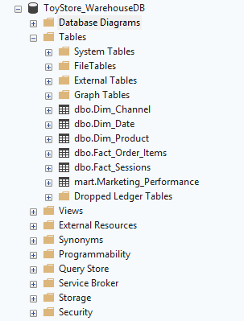

6. Task 5: ETL Process Development

6.1 Extraction
Extraction directly targets the structured source files:
- CSV files (orders, order_items, refunds) are extracted utilizing the native BULK INSERT command.
- JSON files (sessions, pageviews) are processed via OPENROWSET combined with OPENJSON to dynamically parse attributes into relational columns.
- The minimal Excel payload (products) is integrated via direct INSERT statements.

6.2 Transformation
All transformation logic is embedded within 02b_load_warehouse_from_staging.sql.
- Missing Value Handling: ISNULL and NULLIF functions standardize empty tracking tags to 'direct'.
- Calendar Generation: A recursive Common Table Expression (CTE) dynamically constructs Dim_Date spanning the dataset's lifecycle.
- Aggregation: Grouping operations consolidate page views per session and aggregate refund totals per order item.
- Derived Attributes: Boolean flags are generated, notably converted_flag, which asserts true when a session successfully resolves to an order.

6.3 Loading Sequence and Validation
Dependencies dictate the load sequence: Staging Tables → Dimensions (Dim_Date, Dim_Product, Dim_Channel) → Fact Tables (Fact_Sessions, Fact_Order_Items).
Validation Metrics:
- Fact_Order_Items Row Count: Successfully matched staging (40,025 rows).
- Fact_Sessions Row Count: Successfully matched staging (472,871 rows).
- Revenue Verification: Warehouse total ($1,938,509.75) precisely matches staging.
- Refund Verification: Warehouse total ($85,338.69) precisely matches staging.
- Conversion Rate Check: Pipeline yields a realistic benchmark of 6.83% overall conversion.
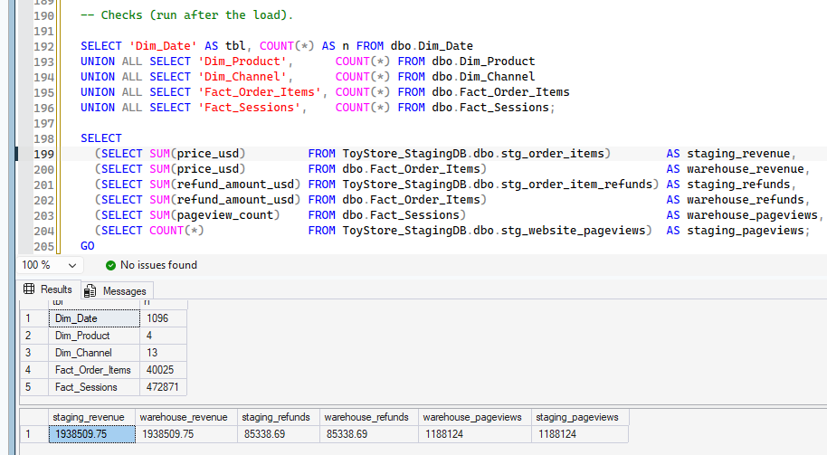

7. Task 6: Data Mart Development
A dedicated "Marketing Performance" data mart was constructed targeting marketing managers and traffic analysts. This mart abstracts the complexity of the core warehouse, presenting an optimized view grouped daily by marketing channel.
The mart consists of a physical table (Marketing_Performance) tracking aggregate sessions and revenue, augmented by a virtualized view (vw_Channel_Performance) that computes analytical ratios such as conversion rates and average order values dynamically. Validations confirm the mart correctly represents 472,871 sessions and $1,938,509.75 in revenue across 10,123 unique date/channel groupings.
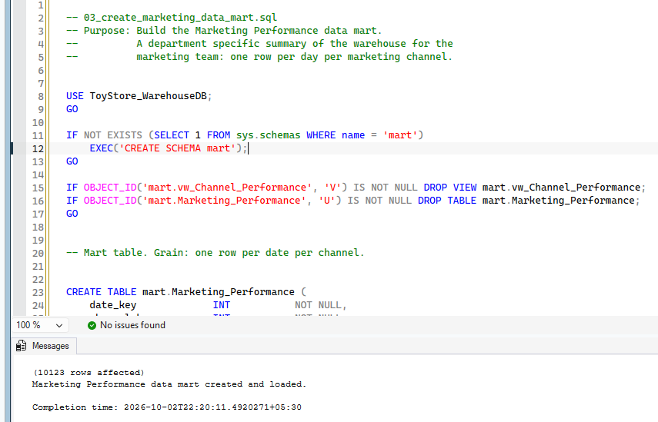

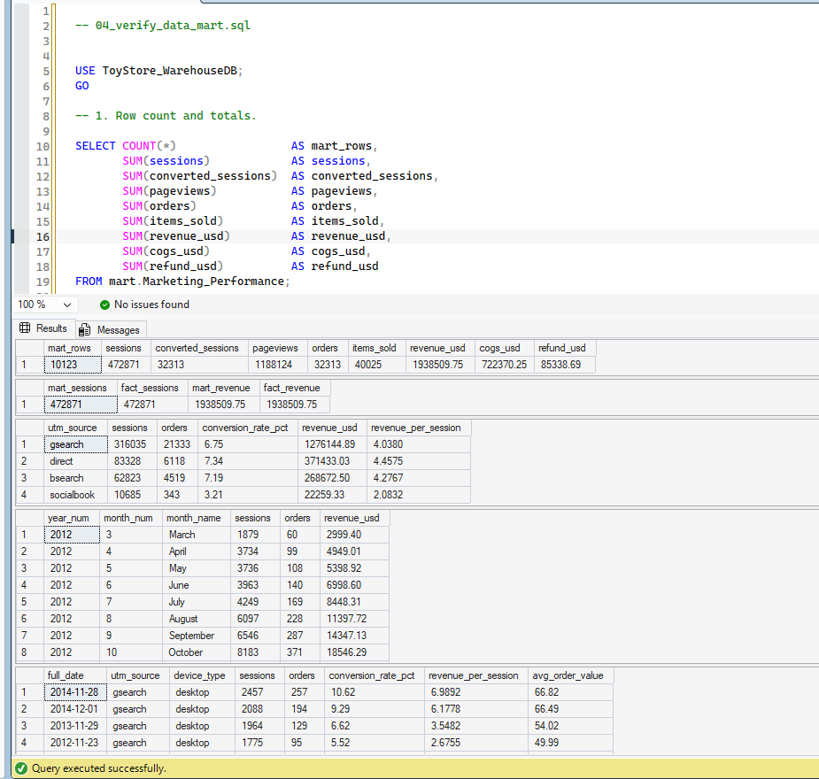

8. Task 7: OLAP Analysis and Business Intelligence Dashboard
The Power BI solution consists of three primary analytical interfaces:

8.1 Report Page 1: Executive Summary
This view provides top-level organizational KPIs including total revenue, orders, sessions, conversion rate, average order value, and refund rate. It features comparative bar charts evaluating revenue strictly by marketing source and volume by product line.

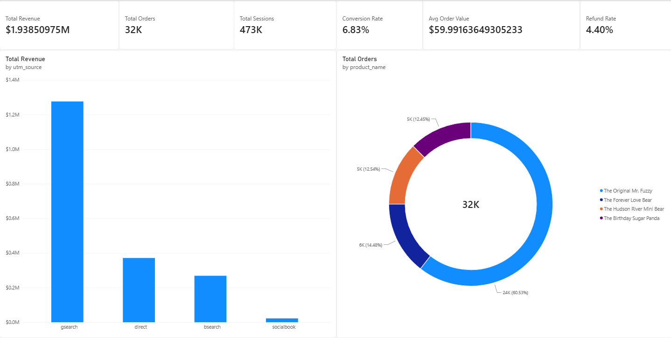

8.2 Report Page 2: Trend Analysis
This view analyzes time-series performance, displaying revenue and traffic trends mapped chronologically. A critical visualization is a clustered column chart tracking channel revenue monthly, preventing chronological distortion across overlapping years.
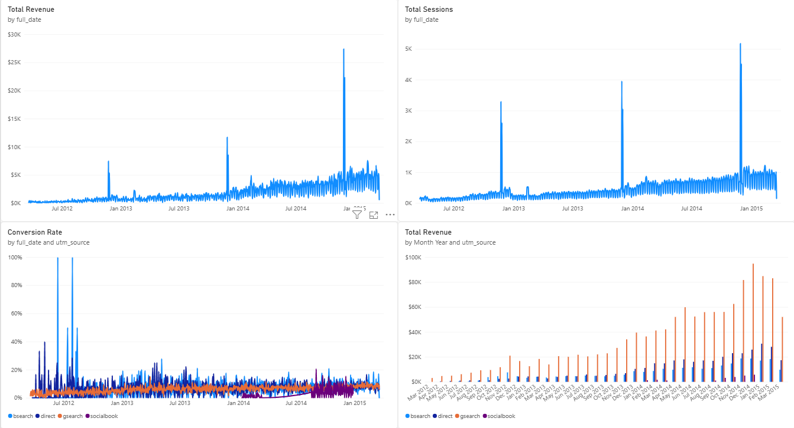
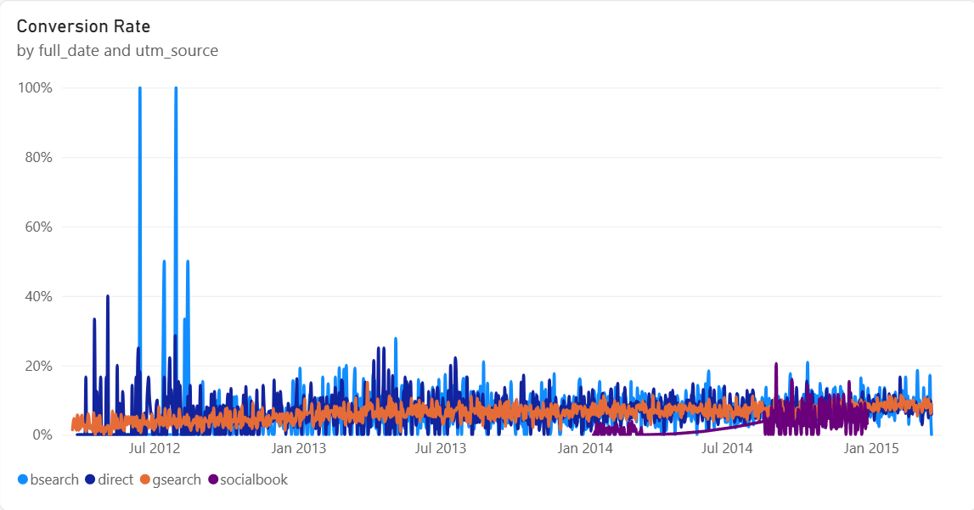

8.3 Report Page 3: Interactive Analysis
This diagnostic page explicitly demonstrates standard OLAP operations:
- Slice: Filtering data via single parameters (e.g., isolating gsearch traffic).
- Dice: Applying multidimensional filters (e.g., gsearch via mobile devices only).
- Drill-down: Expanding the temporal matrix from year down to specific fiscal days.
- Roll-up: Summarizing daily granular data back into quarterly or annual aggregates.
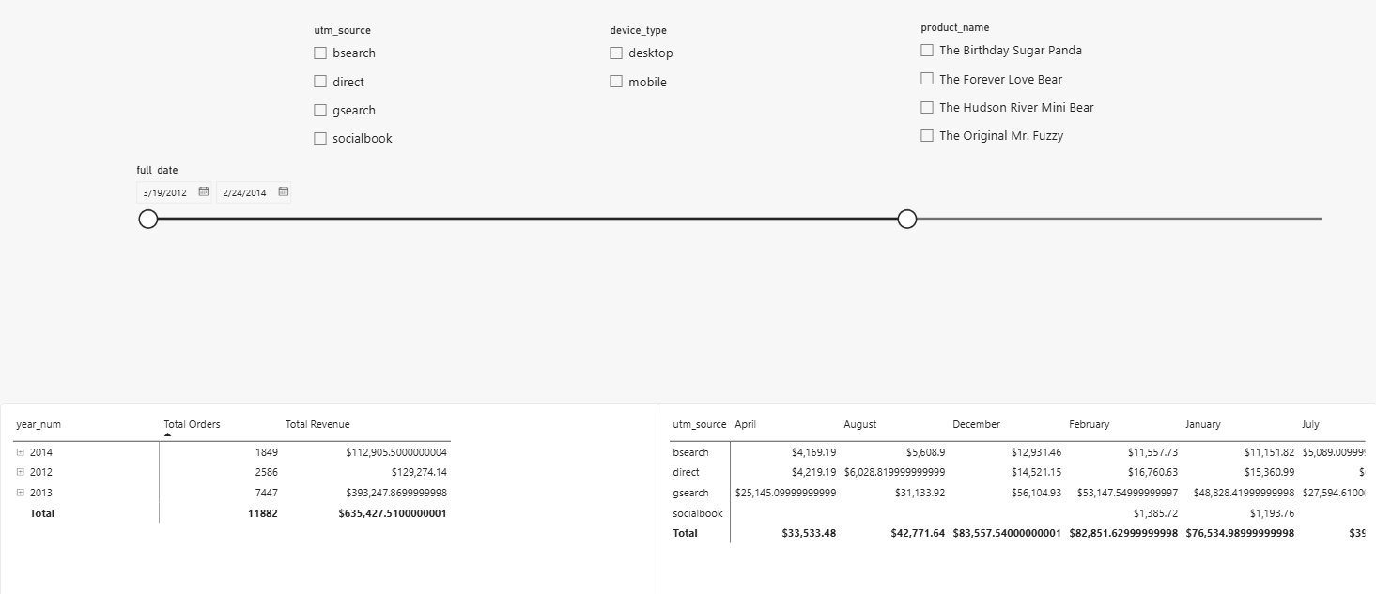

Slice - isolating gsearch traffic
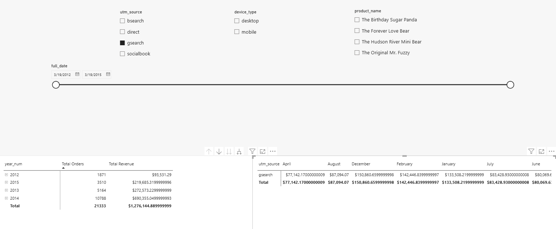
Dice - gsearch via mobile devices only
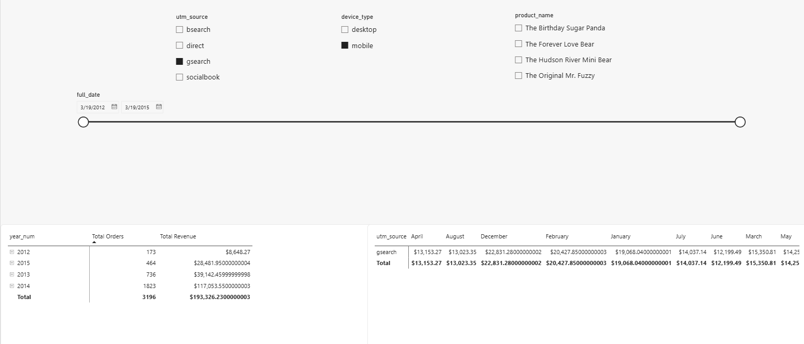
Drill-down - Expanding the temporal matrix from year down to specific fiscal days.
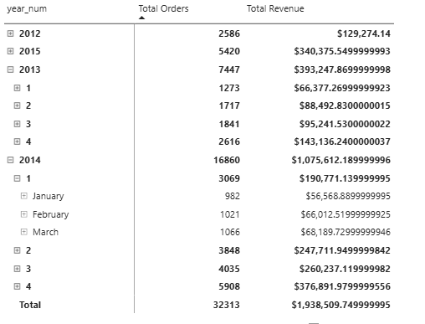

Roll-up - Summarizing daily granular data back into quarterly or annual aggregates.
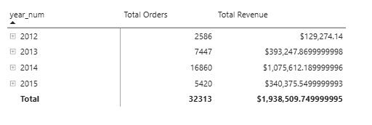

9. Task 8: Business Insights and Recommendations
Based on the dashboard analytics, the following strategic insights are provided:
- Insight: Socialbook traffic converts at merely 3.21%, substantially underperforming compared to gsearch (6.75%), direct traffic (7.34%), and bsearch (7.19%). Recommendation: Temporarily halt budget scaling on Socialbook until user intent, ad targeting, and landing page congruency are audited and optimized.
- Insight: Direct traffic achieves the highest overall conversion rate (7.34%) despite not driving the absolute highest volume of sessions. Recommendation: Allocate resources toward general brand awareness and retention campaigns, as visitors who bypass search engines demonstrate significantly higher purchase intent.
- Insight: A single product ("The Original Mr. Fuzzy") drives approximately 62% of gross revenue ($1,211,057.74 of the $1,938,509.75 total). Recommendation: Diversify the product portfolio marketing. The organization carries immense risk if demand for this flagship item wanes; promotional budgets should test demand elasticity for the secondary products.
- Insight: gsearch constitutes nearly two-thirds of total digital footprint (316,035 sessions) but maintains an average conversion rate (6.75%). Recommendation: Prioritize Conversion Rate Optimization (CRO) specifically on gsearch landing pages. Due to baseline volume, a fractional percentage increase in conversion here yields higher total revenue than massive improvements on smaller channels.
- Insight: The historical refund rate operates at 4.4% of total gross revenue ($85,338.69). Recommendation: Leverage the BI drill-down capabilities to determine if this 4.4% is uniform across the catalog or heavily skewed toward a specific product with manufacturing defects.

10. Acknowledgement of AI Use
Parts of this project, including some of the SQL scripts, the data model design and this documentation, were built with help from an AI assistant. The report has a full section describing exactly how it was used. We ran everything ourselves against our own data and checked the results before including them.

Appendix A: Technical Files Submitted
- prepare_sources.py: Python script for initial file formatting (CSV, Excel, JSON).
- 01_create_staging_tables.sql: Generates architecture in ToyStore_StagingDB.
- 01b_load_staging_from_files.sql: Executes extraction utilizing BULK INSERT and OPENJSON.
- 02_create_warehouse_tables.sql: Establishes dimensional schemas in ToyStore_WarehouseDB.
- 02b_load_warehouse_from_staging.sql: Executes transformation and loading inside a transactional wrapper.
- 03_create_marketing_data_mart.sql: Compiles the aggregated data mart schema.
- 04_verify_data_mart.sql: Diagnostic queries validating mart data integrity.
- Power BI File (.pbix): Contains the interactive BI solution.

